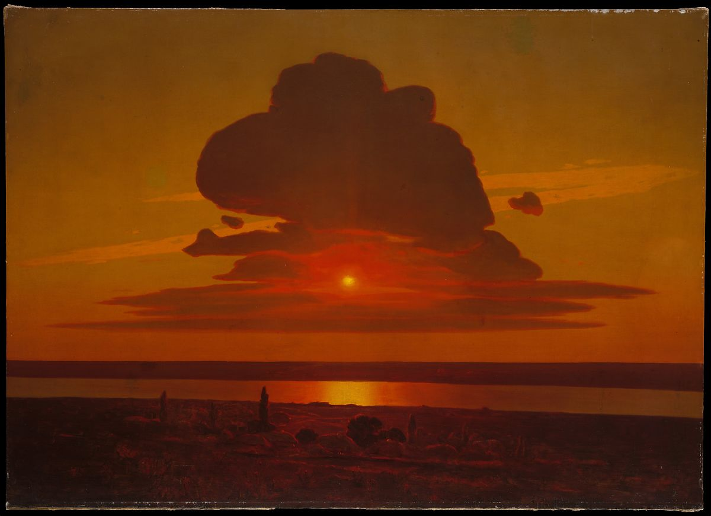
DON’T SPEAK A SLAVIC LANGUAGE? NO PROBLEM!
THESE FALL 2023 COURSES HAVE NO PREREQUISITES!
SLCL 3001 RUSS 3220
Slavic Cultures (GLOBAL CORE) Literature & Empire (19th C. Survey)
Prof. J. Merrill, Prof. C. Harwood, TR 2:40 – 3:555 Prof. J. Wright, TR 10:10 – 11:25
RUSS 3230 CLSL 4011
Tricksters in World Culture (GLOBAL CORE) Experimental Cultures
Prof. M. Lipovetsky, MW 4:10 – 5:25 Prof. A. Boskovic, Prof. C. Caes, T 4:10 – 6:00
CLSL 4012 CLRS 4037
Holocaust Literature: Critical Thinking in Poets, Rebels, Exile: 100 Years of Russians
Dark Times (GLOBAL CORE) and Russian Jews in America
Prof. O. Dynes, W. 10:10 – 12:00 Prof. Anna Katsnelson, R, 2:10 – 4:00
CLSL 4075 CLRS 4213
Post-Colonial & Post-Soviet Cinema Cold War Reason
Prof. Y. Shevchuk, T 6:10 – 10:00 Prof. A. Leeds, M 2:10 – 4:00
CPLS 4740
The Naratology of Modernity
A. Leeds, T 2:10 – 4:00

